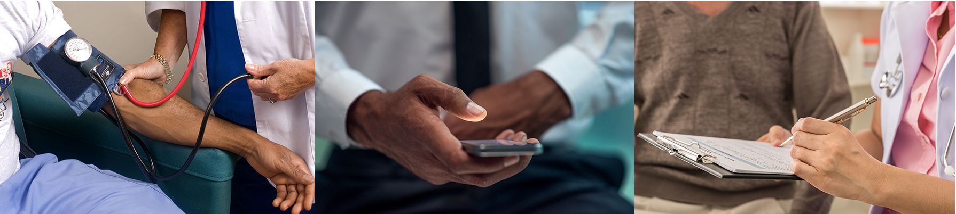

**Addiction Study**

Are you newly recovering from alcoholism?

If so, you are invited to participate in multiple research studies investigating how one’s environment and levels of stress may impact their recovery.

If you join, you will:

* Receive additional addiction support.
* Make 5-8 visits to our Center over three months.
* Earn up to $750 for your participation.
* Know that you are helping others in recovery from alcoholism.

Who can join this research study?

Anyone who:

* Is over the age of 18
* Is newly recovering from alcoholism (1-8 weeks without drinking any alcohol)
* Can read and write in English

What if I want to learn more or join the study?

Call: 608-890-4794

Transportation assistance may be available